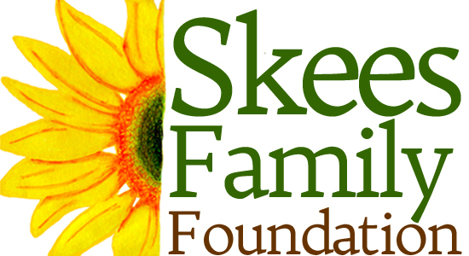

Skees Family Foundation Media Release Form

Thank you for participating in a program and/or interview supported by the Skees Family Foundation.

As is common practice with many nonprofit organizations, the Skees Family Foundation periodically produces online, print, podcast, or video materials, so that a broader audience can learn about our work. Thus, we request your kind permission to illustrate, photograph, record and/or videotape your likeness, voice and/or personal identification.

These materials will be used solely to advance the mission and programs of our foundation and partners. You also retain the right to share your likeness, voice, and/or personal identification that appear in our print and online materials.

By signing this document, you release the Skees Family Foundation from any and all claims in the usage of your likeness, voice and/or personal identification, as incorporated and edited into material including, but not limited to, digital media, advertising, promotion, press releases, video, audio, books and/or other print material.

By signing this release, you also understand that the Skees Family Foundation is unable to provide you with financial or other remuneration for recording your likeness and/or voice, either for initial or subsequent usage and is not responsible for any expense or liability incurred as a result of your participation in this recording, including medical expenses due to any sickness or injury incurred as a result.

I agree with the above provisions and hereby grant the Skees Family Foundation permission as requested above.

Printed name (under 18)______________________________________________________________

Signature of above____________________________________________________________________

Printed name of parent/guardian (if above is under 18)

______________________________________________________________________________________

Signature of above ___________________________________________________________________

Date_____________________________ OK to use last name: Yes___________ No___________

Skees Family Foundation staff________________________________________________________

