You Have 6 Nonprofit Story Types to Tell
By Nancy Schwartz
http://gettingattention.org/articles/nonprofit-marketing-articles.html
As a marketer, you aim to change how people perceive and act on your organization’s work and cause. Connection is the lubricant for those changes, but the drab way so many organizations discuss their work becomes a real barrier to connecting. Instead, it’s a dead end.
Clear messages wrapped in memorable stories (that strike the heart, then the head) are your way out of this trap. Read on to learn about the six story types you already have to tell, and dig into detailed how-tos on three of them. We’ll cover the balance in Part Two, coming soon.
Here are six core story types you’re likely to find in your organization. Your first step is inventorying the stories you have to tell in each category:
- Our Founding: How your organization was created
- Our Focus: The core challenge you tackle
- Our Impact Stories: This most-told nonprofit story features the before and after—shows impact of your organization and supporters
- Our People: Donor, staff, volunteer, client/participant profiles
- Our Strength Stories: How your particular approach adds value to the services you provide, and moves your mission forward
- Our Future: The change you want to make in the world or what your work will lead to.
1) Your Founding Story
The Typical Nonprofit Founding Story— Is yours as deadly as this one? Because you have all the ingredients to make it far more effective.
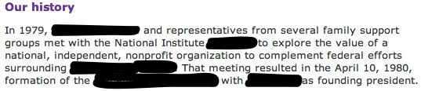
There’s a good possibility that the way you tell your organization’s founding story now is just as passionless, removed and absolutely unmemorable as this one. The great news is that you have the content and the talent to do so much better.
KaBOOM!’s Meaningful, Memorable Founding Story— Your org’s founding story can be as moving and motivating as this one!
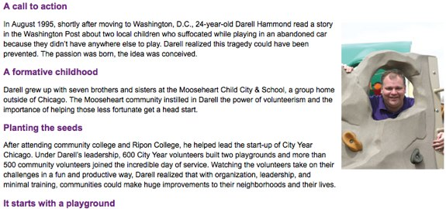
Your founding story can be just as wow, easy-to-relate-to, moving, get-off-your-butt-and-do-something as KaBOOM!’s founding story!
4 steps to power up your organization’s founding story:
- Focus on the founder(s) and what motivated them to start the organization. Get personal, as if she was telling you “the why” at a party or on a car ride. If that info isn’t available, ask relatives, long-time employees and colleagues.
- Drill down into the personal side of that act—did she have a friend with cancer, come from a country that was long in civil war or…? Make the motivation clear, genuine and relatable to your prospects’ experience and point of view.
- Show how your founder clarified her understanding of a problem and possible solution, and the start-up of an organization to help solve it.
- Emphasize each step in the process just as KaBOOM! does in Darell’s story: He moves from a family-bred sense of civic responsibility, to digesting a tragic news story, to acting on those two things by forming City Year Chicago which led to done-in-a-day playground-focused KaBOOM!
When done right, your founding story has the potential to motivate people like you and me to give, volunteer, sign petitions and participate in programs. Strengthen yours today!
2) Your Focus Story
Your focus story is so vital in connecting your work and impact with what matters to your prospects and supporters, so make sure to do it right.
Warning: Telling a good focus story is particularly challenging (and especially vital) for policy organizations, intermediary organizations (e.g. community foundations, United Ways, nonprofit support orgs and others that help nonprofits do their work better and more broadly) and really, for most organizations that don’t provide direct services. Here’s how to do it well.
The Typical Nonprofit Focus Story— Is your focus story as inaccessible (and boring, let’s just say it) as this one? Many are, especially for the organizations that need strong focus stories to clarify what they do and why folks should care.
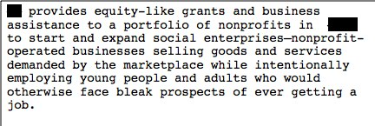
What? I don’t even understand this. It makes me tired.
This is the kind of focus story I see most often from the nonprofits that need a good one most! So it’s likely yours is just as inaccessible, boring and totally forgettable as this one. The great news is that it’s you have the content and the talent to do so much better, and it’s totally doable!
Two Aha! Focus Stories—Connecting the Dots Between Your Work and Your Beneficiaries
Your org’s focus story can be as compelling, moving and motivating as these two! Visuals are a great help.
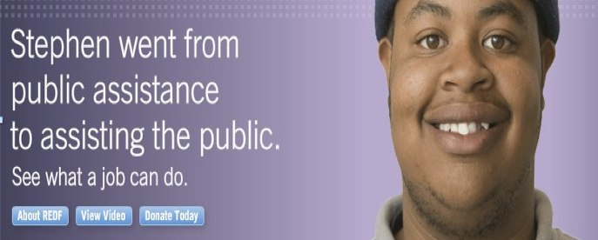

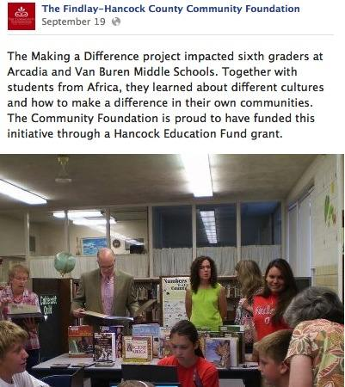

3 steps to power up your organization’s focus story:
- Connect the dots between your organization’s work and impact and your ultimate beneficiaries, even if there are layers in between.
- Get detailed and personal, as if you’re telling his or her story to someone who knows nothing about it. The details are what sticks (or not), and make your story memorable and more likely to be repeated.
- Include visuals if at all possible—they really can be worth 1,000 words!
When done right, your focus story has the potential to motivate people like you and me to give, volunteer, sign petitions and participate in programs. Dive into shaping yours now!
3) Your Success Stories
Success stories (a.k.a. impact stories) are the stories most frequently told. And, when done right, these stories are unequaled in showing the value of your organization’s work in moving your issue or cause forward and matching the personal goals of prospects and supporters.
The great thing is that you have many of these success stories to tell, and the potential for using them to move your people to the actions you want is huge. So invest the time and effort it takes to do them right.
Two Aha! Success Stories— Showing the Before and After in a Memorable Way

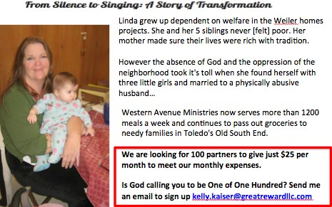
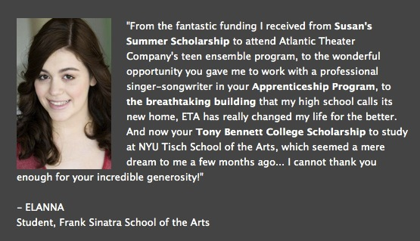

5 Steps to Strengthen Your Success Stories
Your org’s impact stories will be as compelling, moving and motivating as these two when you follow these steps:
- Focus on the difference your organization’s work makes in the life of someone (keep it to a single person or a family in each story if you can).
- Outline the before and the after in an emotional way.
- Dig into the details—they allow the reader or listener to feel your story, not just process it. What’s felt is much more likely to be remembered and acted on.
- Testimonials, with a face and name if possible, are the ideal format here.
- Close with a call to action, like the top example here!
You already have these stories on hand. And if you don’t have the details and permissions that will make them even stronger, go back and get those elements for recent stories and start collecting them proactively going forward.
When done right, your impact stories have the potential to motivate people like you and me to give, volunteer, sign petitions and participate in programs. Get on them!

- See more at: http://gettingattention.org/articles/3994/nonprofit-storytelling/nonprofit-story-types.html#sthash.r0PTChfg.dpuf

